Week 6 | Monday – Friday It would be lovely to see your work on facebook or when we are all back to school.
Physical Development  Expressive Art & Design | Go Noodle  https://www.gonoodle.com/good-energy-at-home-kids-games-and-videos/  Exercise Songs for Kids ♫Brain Breaks Run and Walk -The Learning Station  https://www.youtube.com/watch?v=j7qdWyHMjwE
Literacy (story based) | The Nursery texts will be based on Pirates this week.You can chose to read one of the stories or read both. Please follow the activities at your own pace.  Pirates Love Underpants https://www.youtube.com/watch?v=Vd8_Y1bEzA8  My Granny is a Pirate https://www.youtube.com/watch?v=t8ZKIvRblpM  *After listening to the story, talk about what happened at the beginning, midde and end.  *Discuss the illustrations/pictures – talk about what is happening.  *Make up super sentences about a pirate e.g One sunny day the tall pirate held a brighty coloured parot.  *Copy/write your name.
Maths | For this week, please follow the Reception lessons, one lesson a day if you can.  https://whiterosemaths.com/homelearning/early-years/  Number rhyme song ‘5 Little monkeys’ https://www.topmarks.co.uk/Flash.aspx?bbc=fivelittlemonkeys  If you would like do extra practical activities then that would be great. Constant repetition will be beneficial for your child. Please refer to the maths activities and nursery non negotiables given previousy by parentmail on the 28th of April.
Phonics/spellings | *Can you find/think of any words that begin with: P (just like pirate) Sh (just like ship) B (just like boat) H (just like hat)  *Can you find/think of any words that rhyme with: Flag, boat, ship, parrot and hat *Blending – b-oa-t, sh-i-p b-ir-d m-a-p s-ea
Finger strengthening | Cutting skills using kitchen roll tubes. Make a pirate  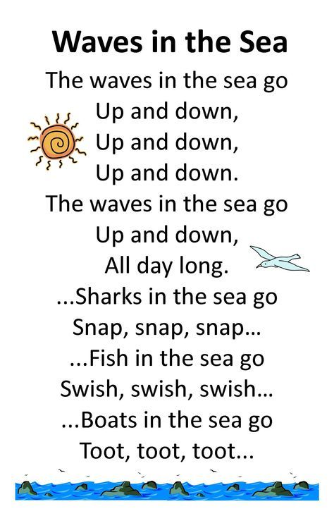  Use fingers and hands to add actions to the song.
Topic | Choose as many activities as you would like to complete.  *All pirates have a flag that is special to them! They display them proudly on their ships. Can you make your own? All you need is a blank piece of paper and something to hold it with (a straw, a spoon etc.)  *Make a pirate hat.  *If you would like an eye patch, you could make one with just paper or card and attach it with string or even a shoelace!  *Make a treasure box – count the treasure as you put it in the box  *Don’t forget your map! Use your pencil skills to help draw a map of your house. Don’t forget that X marks the spot! Use your map to go on a treasure hunt.  * Pirates are super creative. They can make music out of anything! This includes homemade instruments, pots and pans, body percussion and so much more! Can yu make some music?  *Build yiur own pirate ship.

