Suggested activities to do at home – Year 1
These are just a few ideas to get you started. We will be adding to the content of this page.
The BBC will also be producing daily lesson for each year group.

PSHE
- Make a healthy wrap- Discuss what foods are healthy and unhealthy, what makes this wrap a healthy one? Encourage the use of time related language (first, next, then). Take a photo of preparation and finished wrap at the end.
- Self-portrait- Look at the differences between you and someone in your house or one of your friends (different hair colour, different eye colour, different heights). Discuss what makes us all different and why it’s important to respect everyone.
- Drama- How do you know how someone is feeling other than their facial expressions?
Cut pictures of faces out of magazines or newspapers. Put them in a bag. Pull out a face and act it out to someone. They will have to guess how you are feeling. You can do lots of actions to go with your facial expression. If you are angry you might stamp your feet. What could you do if you were sad, happy, embarrassed, thinking, worried etc?
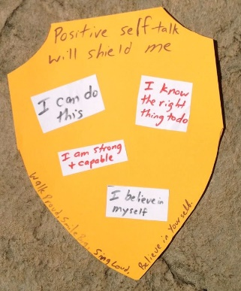
- Self-talk shield- Create a self-talk shield to emphasise the importance of positive self-talk and a positive mind-set. What are you good at? What are the great things about you?
If possible, relate to Dinnington ROCKS (resilience, open to new experiences, community, kindness and success).

History
- Toy fact file- Discuss the differences between toys in the past and the present (materials, what they are used for, how they’re played with). Pick your favourite toy and write about how it is different from toys in the past.
- Research project- Find out as much information as you can about someone from the past who you think is interesting. You can bring this back into school and share it with the class when we come back.

Music
- In Year 1 we love to sing lots of different songs. Share some of our favourite songs at home:
Mamma Mia- ABBA
I Like the Flowers
Down in the Jungle
Don’t Stop Believin’- Journey
Happy- Pharrell Williams
- Make a dance up to your favourite song and perform it for someone.
- Use your recorder- Practice notes we know already such as B, A, D and G.
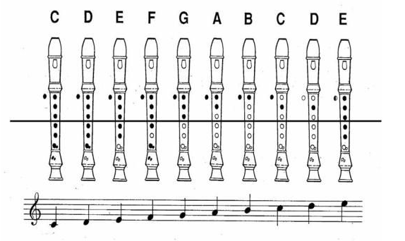
You can practise this one for Easter
PE
- Star jumps- How many star jumps can you do in 30 seconds? Can you beat your record? Talk about how long 30 seconds is, did it feel like a long time? Can you count your own jumps? How many more/less do you do each time?
- In Year 1 we use BBC Super movers to help us learn whilst also staying active. There are many videos to move along with on various topics within Maths, English and PSHE. Search online for BBC Supermovers or click the link: https://www.bbc.co.uk/teach/supermovers/ks1-collection/zbr4scw
- Create a free login to GoNoodle and pick a video to dance along to, our favourites are: Pop See Ko, Milkshake and anything by KidzBop!

Science
- Plant hunt- Look outside at your garden. List all of the plants you can see, are they wild or garden plants? What is the difference? Can you name them all?
- Draw a picture of your favourite plant and label it as a wild or garden plant.
- Go on a walk. What trees can you see? Can you identify them from the leaves?

- Find objects in your house made from different materials.
Find an object made of each of these materials.
Wood
Plastic
Cotton
Paper
Cardboard
Glass
Metal
Talk with an adult about why you think this material was chosen for this object. (discuss why glass wouldn’t work for a football etc)
Computing
- Make a stop motion animation using ‘Stop Motion Animation App’ – there are lots of others available.
Mark a spot on a table with washable pen / piece of sellotape. Put an apple on the spot. Take a bite and put the apple back. Repeat until the apple is down to the core.
Watch your film back!
Top tip: Put the apple back the same way each time.

- Staying safe online- How can we stay safe online? Why is it important to be safe when using the internet? Make a poster all about internet safety.

- Discuss different scenarios and how to respond to them (someone is being mean to you online, an advert pops up to enter a competition, someone you don’t know tries to talk to you).

Maths
- Learn your ‘number bonds to 1o’ off by heart
Ask an adult to write lots of them down for you and see how many you get right in one minute. Do this every day and see if you get faster at it. Start with just addition and then once you are very quick at this mix up addition and subtraction.
You should know all of these off by heart.
e.g
1+5= 6+1=
3+8= 4+6=
Once you can do these very quickly then start on the bonds to 20.

- Find pairs- Find pairs of items in your house such as shoes, socks and gloves. Count in 2’s, forwards and backwards.
- Find different food packets- Compare different packets of food by weight, lifting them and also reading the weight measurement displayed. Use language such as heavier, lighter, less and more to compare.
- Number hunt- Explore your home and record the different numbers you can see. Compare, order and sort the numbers you find. Then, look outside at the number on your house and the numbers on the houses around you. Which numbers are bigger/smaller and which are odd/even?
- Toy ordering- Find 5 toys and put them in order of height. They can be ordered from shortest to tallest or tallest to shortest. Use language to compare the toys (taller than, shorter than) and write a sentence to describe what you’ve found.
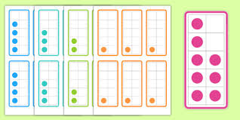
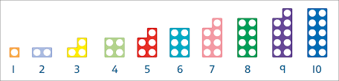
- Roll a dice- Roll a dice to generate a number and find different objects around the house to represent it (four spoons, four forks, four shoes). Then, draw a numicon and tens frame representation of the number.
Numicon
Tens frame

- Shape hunt- Search for objects that are different 3D shapes and name them (sphere, cone, cylinder, cube, cuboid). Can you sort them?

English
- Find objects around your house and use your phonics to label them. Make your own shop by putting prices on them.
- Read a story or poem every day (the oxford owl website has free ebooks).
- Write a story to cheer someone up.
Once upon a time there was a …….. who lived in a………... .
They were very happy until one day…….
- Write messages and hide them around the house. Don’t forget your capital letters and full stops.
- Write instructions- Write a set of instructions about how to play your favourite game. Remember to include what you will need, numbered steps and time words.
- Write a letter to someone who you can’t go and visit at the moment.
- Retell a story we have learned in class this year:
Man on the Moon (A Day in the Life of Bob) by Simon Bartram
The Gruffalo by Julia Donaldson
Jim and the Beanstalk by Raymond Briggs
Little Red Riding Hood
Hansel and Gretel
Or choose your own favourite story to retell!

You could get someone to film you doing this and watch it back.

