Handwriting and
Presentation Policy
2019-20

Safeguarding Statement

Everyone at Dinnington First School shares and objective to keep children and young people safe by contributing to:

- Providing a safe environment for young people to learn in school
- Identifying children and young people who are suffering or likely to suffer significant harm, and taking appropriate action with the aim of making sure they are kept safe both at home and at school

Agreed October 2019

Rationale and Aims
The purpose of this policy is to set out a whole school approach to presentation and the teaching of handwriting that has been agreed by the whole staff and the governing body following discussions, consultation and professional development.
It provides guidance for all staff, new and experienced and it will underpin the teaching of handwriting and presentation throughout the curriculum.
Our Vision: Learn, Enjoy, Succeed Together
A community that works hard and supports each other to be the best that we can be
The intent of our curriculum is founded in delivering the National Curriculum and tailoring it our children through our vision and values.
Values: Dinnington R.O.C.K.S
- Resilient: To create independent learners who are self-motivated, problem solvers and life-long learners. To LEARN through working hard, being determined, motivated and adaptable.
- Open to new experiences: To inspire enthusiasm for learning for life; to provide an inspirational range of experiences to develop the whole child both in and outside of the classroom; for children to ENJOY learning and embrace new experiences and challenges and discover ‘what makes them tick’.
- Community Spirit: To be a welcoming and inclusive school. To create rounded children for the future who see the benefits of collaboration and teamwork in the pursuit of happiness and success.
- Kindness: To actively teach kindness, consideration and respect so that it permeates our lives and the lives of others; To promote self-belief and belief in others; To acknowledge that everyone is different but to celebrate our differences. To understand we need to be kind and look after ourselves, others and to the environment.
- Success: To provide a progressive, sequential curriculum across all subject areas and to cater for the differing needs of all our children in terms of knowledge, skills and abilities. To celebrate everyone’s successes in all areas of life. We recognise that we all have different strengths and are proud when we work hard and when we SUCCEED TOGETHER.

Aims:
- For all children to develop a neat, fluent and legible cursive handwriting style with correctly formed letters
- To have a consistent approach to teaching handwriting and presentation throughout school
- To ensure high expectations of all children
- To adopt a common approach towards handwriting that is modelled by teachers and support staff working with children
Strategy for implementation:
Entitlement and curriculum provision
Handwriting is to be taught daily through short focused sessions and maybe linked with spelling, grammar or phonics.
Teaching and Learning
Handwriting is a skill which needs to be taught explicitly. Since handwriting is essentially a movement skill, correct modelling of the agreed style by the teacher is very important; it is not sufficient to require pupils to copy models.
The role of the teacher
- To follow school policy to help each child develop fluent, legible, cursive handwriting.
- To provide direct teaching and accurate modelling
- To provide resources and an environment that promotes good handwriting e.g. handwriting model clearly displayed in classroom
- To observe pupils, monitor progress and determine targets for development
- To provide extra support for children who are not working within age related expectations or who are in danger of falling behind

Continuity and Progression
Formal handwriting is taught through the Nelson Handwriting Scheme
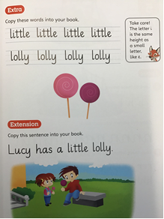
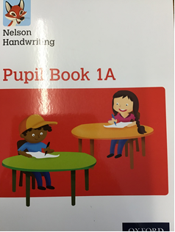

Foundation Stage

The emphasis at this stage is with movement and fine motor skill development. Letter formation (starting at the right entry point and then moving in the right direction) learned at this early stage becomes automatic and has a profound influence on later fluency, legibility and automaticity.

To aid fluency great attention is paid to pencil grip (nip and flick), correct posture, the positioning of the paper and the organisation of the writing space. Teachers are vigilant to ensure bad habits do not become engrained and that the specific needs of left-handed children or those with special educational needs are met.

Key Stage 1

Building on the foundation stage, pupils at Key Stage 1 develop a legible style and begin to use fully cursive handwriting by starting to join their letters in Year 1. By the end of Key Stage 1 it is expected that the majority of children will be joining. Correct letter orientation, formation and proportion are taught in line with the Nelson Handwriting Scheme.

Key Stage 2

The target for children in Key Stage 2 is to produce a fluent, consistently formed style of cursive handwriting with equal spacing between the letters and words.

By Year 4 the children will be using a pen to complete the majority of their work using a fully cursive style where appropriate.
Pencils will be used in mathematics work and for drawing and completion of diagrams e.g. in science

Presentation Guidance

Book covers should indicate:

- Child’s name
- Class
- Subject
- Children will be encouraged to take care of their books and be proud of them

Date and Title of work in books:

DUMTUMS

Date, Underline, Miss a line, Title, Underline, Miss a line

- Full written date in books except mathematics when the number date format will be used.
- Date is written on the top line and underlined with a ruler

Title:

- Key Knowledge (KK) should be written for each piece of work underlined with a ruler aligned to the left margin

Key Knowledge should state clearly the main learning that will take place within the lesson or over a series of lessons.

e.g. KK: To name the capital cities of the UK
KK: To use alternative words to ‘said’ in dialogue
KK: Understand the value of the digit in the Th column
KK: Read fluently at 90 words per minute
KK: Spell common exception words correctly
KK: Write a recount using correct past tense of verbs
KK: Explain some of the ways the Romans affected life today

Underlining:

- Children always use a ruler to underline their work

Maths books:

All figures including mathematical signs and symbols are written neatly with one figure in each square
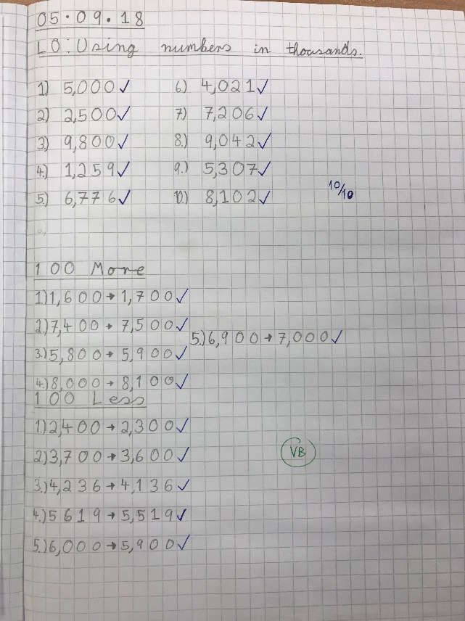

Corrections

- Small corrections can be corrected using a rubber. Children in Key Stage 2 should progress towards making one horizontal line using a ruler to indicate a mistake. The correction is made on the line beside the mistake. Mistakes should not be scribbled out.

- If a large section of writing is incorrect a small x at the beginning of each line can be used.

Monitoring

- Presentation and handwriting will be monitored regularly by the class teachers and the senior leadership team.
- The English subject leader will report on handwriting and presentation as part of the annual subject audit, and set targets as part of the whole school action plan, if necessary.
- The governors will monitor the policy and guidelines and review these regularly.
- Monitoring will be done through lesson observation, work scrutiny, sampling and moderation of pupil writing, data analysis, monitoring of planning.

