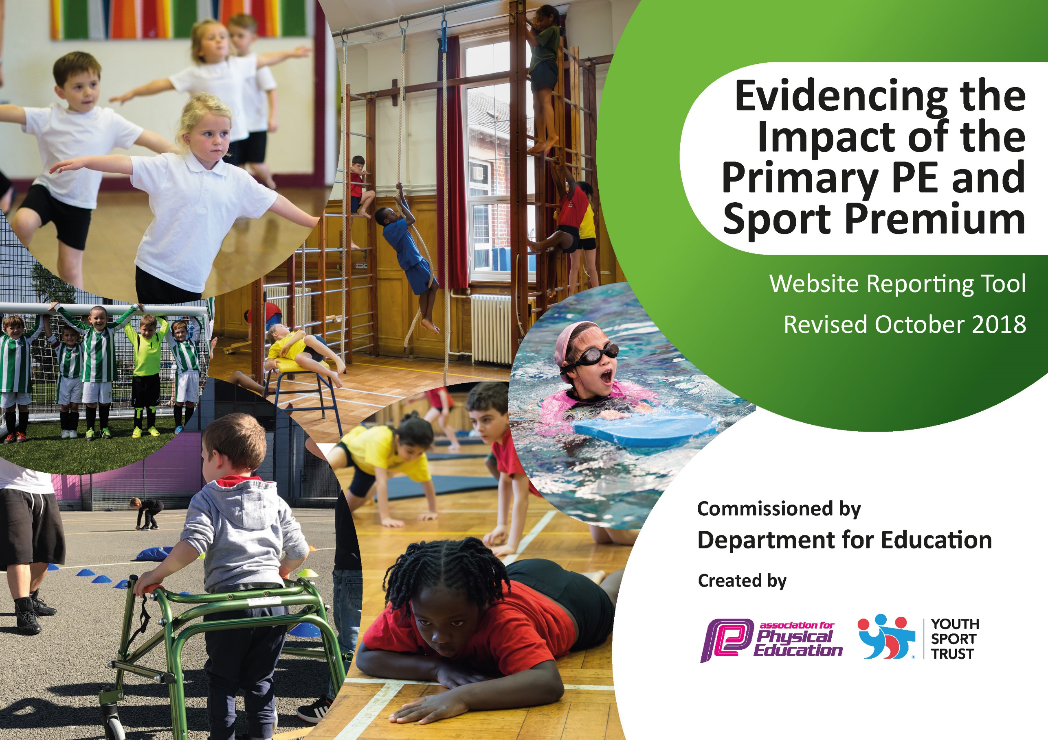
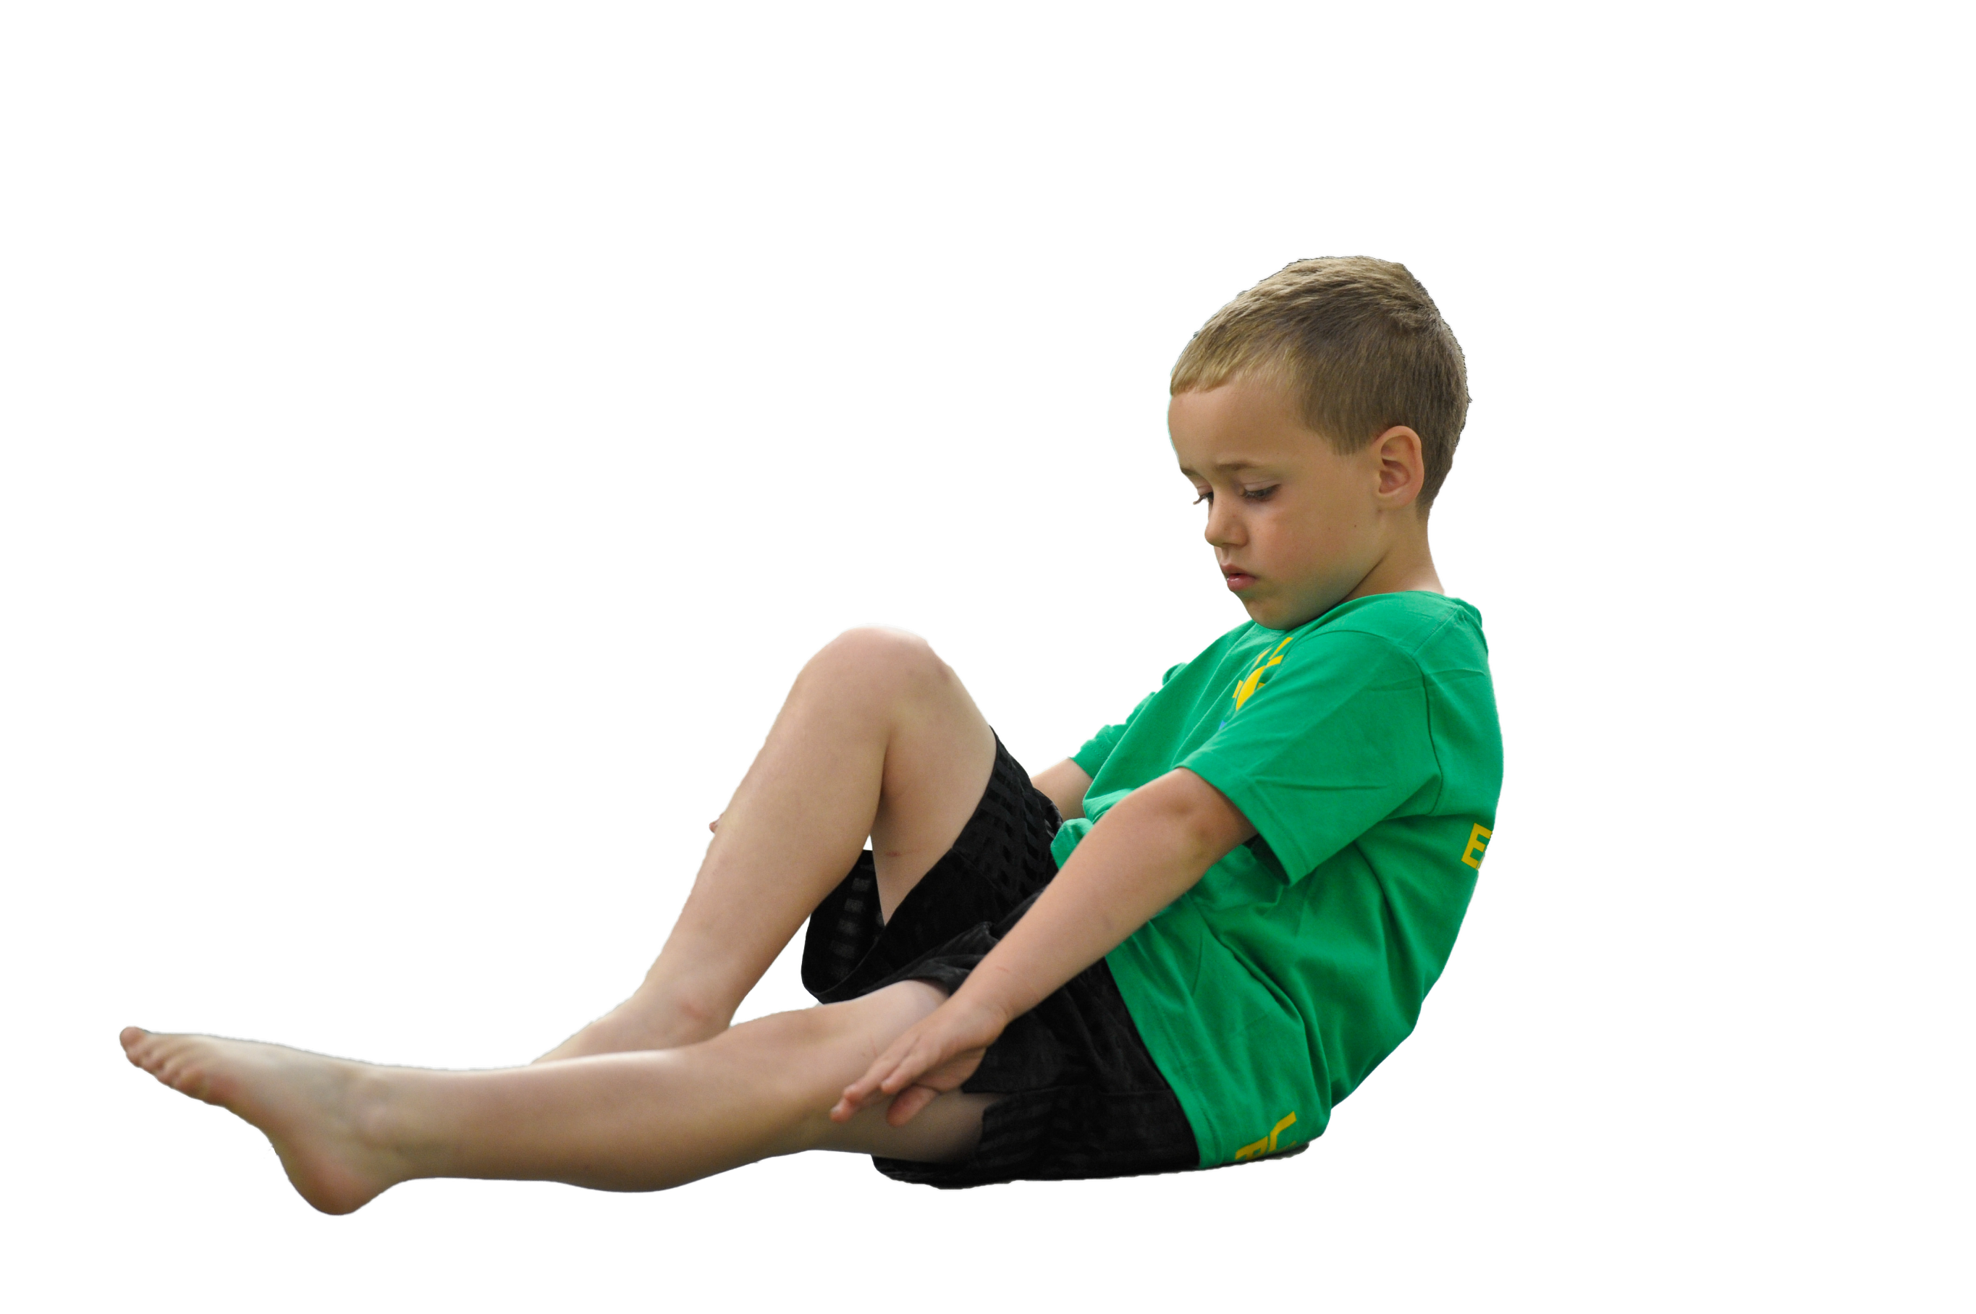
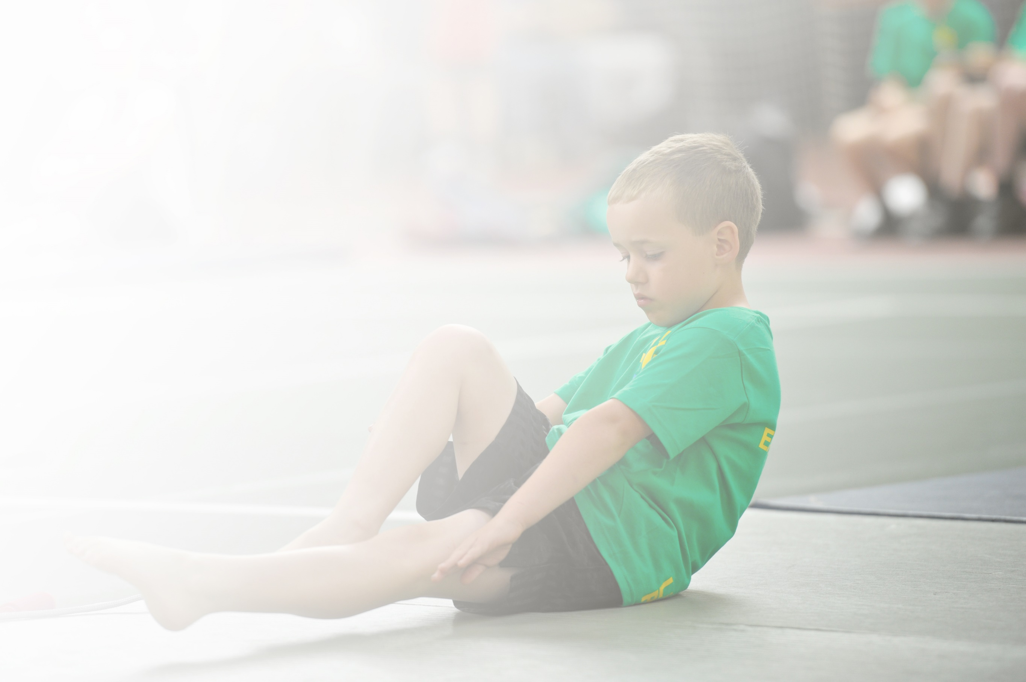
Schools must use the funding to make additional and sustainable improvements to the quality of Physical Education, Sport and Physical Activity (PESPA) they offer. This means that you should use the Primary PE and Sport Premium to:

- Develop or add to the PESPA activities that your school already offer
- Build capacity and capability within the school to ensure that improvements made now will benefit pupils joining the school in future years

Please visit gov.uk for the revised DfE guidance including the 5 key indicators across which schools should demonstrate an improvement. This document will help you to review your provision and to report
your spend. DfE encourages schools to use this template as an effective way of meeting the reporting requirements of the Primary PE and Sport Premium.

We recommend you start by reflecting on the impact of current provision and reviewing the previous
spend. Under the Ofsted Schools Inspection Framework, inspectors will assess how effectively leaders use the Primary PE and Sport Premium and measure its impact on outcomes for pupils, and how effectively governors hold them to account for this.

Schools are required to publish details of how they spend this funding as well as on the impact it has on pupils’ PE and sport participation and attainment by the end of the summer term or by 31 July 2019 at the
latest.
We recommend regularly updating the table and publishing it
on your website throughout the year, as evidence of your
ongoing review into how you are using the money to
secure maximum, sustainable impact. To see an
example of how to complete the table please
click HERE.

Support for review and reflection - considering the 5 key indicators from DfE, what development needs are a priority for your setting and your students now and why? Use the space below to reflect on previous spend, identify current need and priorities for the future.

Key achievements to date: | Areas for further improvement and baseline evidence of need:
- Improved participation of girls in sport through targeted dance club. This meant that 100% of Year 4 girls and 60% of Year 3 girls took part in at least one sporting club.  - Improved staff confidence in delivering dance and gymnastics through paired teaching with a lead teacher. KS1 staff are confident in running a curriculum to allow participation in Newcastle Dance Festival.  - Started to introduce new sports to the curriculum in KS2 – Dodge Ball SAQ.  - Participated in increased sporting competition through the Gosforth School Trust.  - PE Lead has attended training and worked alongside specialists to increase knowledge, expertise and ability to support staff in school.  - School sweatshirts for staff to wear for delivery of sport has helped raise the profile of PE within school. | - Identify any areas of the curriculum that staff feel they are less confident in and put in place the support required.  - Develop staff ability to deliver a wider range of sports in the curriculum.  - Continue to develop the role of the PE lead.  - Invest in sporting equipment to allow delivery of new sports.  - Refine tracking of pupils to enable progress to be shown  - Introduce more competitive elements into the school curriculum.  - Start the daily mile challenge.  - Look into training for LSAs to create more capacity to deliver varied and sustainable sporting options.  - Look at ways to develop gifted and talented children

Meeting national curriculum requirements for swimming and water safety | Please complete all of the below:
What percentage of your current Year 6 cohort swim competently, confidently and proficiently over a distance of at least 25 metres?  N.B. Even though your children may swim in another year please report on their attainment on leaving  primary school. | 100% of Year 3 and 97% of Year 4 pupils have attended swimming lessons.  _____ % of Year 4 can swim 25m  _____ % of Year 3 can swim 25m
What percentage of your current Year 6 cohort use a range of strokes effectively [for example, front crawl, backstroke and breaststroke]? | _____ % of Year 4 can use a range of strokes effectively.  _____ % of Year 3 can use a range of strokes effectively.
What percentage of your current Year 6 cohort perform safe self-rescue in different water-based situations? | ______% can perform safe self-rescue in different water based situations.
Schools can choose to use the Primary PE and Sport Premium to provide additional provision for swimming but this must be for activity over and above the national curriculum requirements. Have you used it in this way? | Yes/No

Action Plan and Budget Tracking
Capture your intended annual spend against the 5 key indicators. Clarify the success criteria and evidence of impact that you intend to measure to evaluate for students today and for the future.

Academic Year: 2018/19 | Total fund allocated: £ | Date Updated: April 2019
Key indicator 1: The engagement of all pupils in regular physical activity – Chief Medical Officer guidelines recommend that primary school children undertake at least 30 minutes of physical activity a day in school |  |  |  | Percentage of total allocation:
 |  |  |  | %
School focus with clarity on intended impact on pupils: | Actions to achieve: | Funding allocated: | Evidence and impact: | Sustainability and suggested next steps:
- Ensure the curriculum ensures every child has high quality PE lessons that inspire pupils to want to join in. At least 2 hours of sports lessons each week will be delivered.  - Introduce the daily mile so that ALL pupils take part in exercise EVERY day, including those when they do not have timetabled PE lessons.  - Buy equipment to encourage active play during break and lunch times. Set up sports challenges.  - Run extra curricula clubs targeted at particular year groups to increase participation of pupils.  - Raise the profile of sport in the school through the use of the school website and social media so that pupils and parents want to take part.  - Raise the profile of sporting opportunities within the community to help families spot opportunities for regular physical activity.  - Encourage pupils to come to school by walking, scooting, on their bike or other healthy method  - Use initiatives such as The Big Pedal to engage a greater range of pupils and families in regular physical activity. | - All staff in KS1 and 2 are to plan for at least 2 hours PE each week.  - Pupil surveys and curriculum walks will be used to monitor engagement.  - The Daily mile will be incorporated into all year groups from EYFS to Year 4.  - Playground equipment should be identified through discussions with pupils, staff and the school council. Once purchased any training should be delivered and sporting challenges set to ensure measurable use.  - Identify opportunities to run extra curricula clubs for pupils in KS1 and KS 2. Target any children (G&T or disadvantaged) that would benefit from taking part. Book coaches if staff are unable to run the clubs. Look into running lunchtime clubs if after school proves problematic.  - Set up a sports section on the school website. Publish sporting success, local opportunities and photos that celebrate pupil achievement.  - Using school / class Twitter accounts celebrate pupil participation and achievement in sporting activities.  - Educate pupils and parents on the need to be active and healthy. Monitor how pupils travel to school and reward those who choose an ‘active’ method regularly.  - Sign up to The Big Pedal and run it over a 2 week period. |  | - Lesson timetables demonstrate at least 2 hours PE allocations.  - Curriculum walks and pupil surveys demonstrate high levels of engagement.  - 100% of children in KS1 and 2 can run / walk 1 mile. Pupils can comment on the positive effects the exercise has had.  - Daily mile to be celebrated as part of assembly and rewards for high performing classes.  - Playtime equipment is purchased and used to set up sport challenges. Staff on duty are able to support play.  - Playground markings enable and encourage pupils to play actively.  - Website sports section set up and used with Twitter to celebrate participation and achievement as well as sharing links within the community.  - Sports clubs run by staff or external coaches are used to offer additional opportunities.  - Travel Tracker is used to monitor how pupils travel to school. A high proportion of pupils will choose to use an ‘active’ method.  - Big Pedal is run starting with a family breakfast to raise the profile. Pupil travel decisions are monitored over a 2 week period, in which increased activity is demonstrated. | - Can children start to record distances / times to enable improvement to be measured?  - Look into including Go-Noodle or similar activity to morning / afternoon sessions.  - Increase the number of extra curricula sports clubs being run.  - Maintain and improve school webstie PE section.  - Continue to use social media to promote sport.  - Invite local clubs to run taster sessions and carry out school assemblies.  - Investigate yard markings to help define play areas to reduce accidents due to collisions / congestion.  - Train Lunch supervisors to help run organised play.  - Continue to encourage health methods of travel to school.

Key indicator 2: The profile of PESSPA (Physical Education, Sport and Physical Activity) being raised across the school as a tool for whole school improvement |  |  |  | Percentage of total allocation:
 |  |  |  | %
School focus with clarity on intended impact on pupils: | Actions to achieve: | Funding allocated: | Evidence and impact: | Sustainability and suggested next steps:
- Buy into SLA for PE to ensure that staff and pupil sporting opportunities are maximised  - Raise the profile of sport in the school through the use of the school website and social media so that pupils and parents want to take part.  - Set up a school PE display to highlight the sporting opportunities and successes in school.  - Raise the profile of sporting opportunities within the community to help families spot opportunities for regular physical activity.  - Celebration assemblies to highlight the importance of PE in and outside school. Promote team and individual achievements  - To promote competition during school both in lessons and sports day with 1 st, 2nd & 3rd stickers as well excellent effort stickers and trophies for outstanding achievement.  - Promote sport through fundraising activities.  - Promote sports in the local community.  - In the summer term run a sports week to allow pupils and parents to try new sports.  - Increase pupils understanding of healthy lifestyle including diet and nutrition and how it links to sport performance.  - Establish leadership roles for older pupils which incorporate challenge into playtime activities in order to develop positive role models for younger children and resilience and confidence for older pupil | - Buy in SLA at bronze level.  - Set up a sports section on the school website. Publish sporting success, local opportunities and photos that celebrate pupil achievement.  - Using school / class Twitter accounts celebrate pupil participation and achievement in sporting activities.  - PE Notice board to be assigned in school hall and used to display sports information.  - Achievements celebrated in assemblies – children presented with certificates, awards and trophies.  - Purchase of reward stickers for sports day  - Each sporting unit delivered in KS1 and 2 ends with a competitive session in which prizes are awarded for excellent performance / improvement / participation / sportsmanship. (Prizes / stickers to be purchased)  - Promote holiday sports programs and sports clubs in the local area.  - Timetable a sports themed week in the summer term in which pupils and parents are invited to try their hand at different sports. This could also be used as an opportunity for local clubs to visit and advertise.  - Book a visiting speaker to inform pupils in KS1 and 2 about health eating and the dangers of using ‘Sports Drinks’.  - Provide training for pupils to become sports leaders. Invest in sports uniforms for leaders to wear. |  | - Attend SLA run workshops and disseminate information to staff, pupils and families as required.  - Website sports section set up and used with Twitter to celebrate participation and achievement as well as sharing links within the community. Pupils and parents aware of sporting success.  - Pupils are keen to see what is on the school PE board and are motivated to try new sports.  - Children who have been part of a competitive teams have all been rewarded in assemblies.  - All pupils to take part in competitive sport within school and understand the values of sportsmanship and improving personal goals.  - Children excited to share their performances with parents and other family members.  - Children enthusiastic to take part during sports days.  - Handed out leaflets, holiday programs and posters to children on a half termly basis.  - Warburtons visit to talk about balanced diet. Pupils make a healthy snack and understand the dangers of using sports drinks at a young age.  - Sports leaders to deliver playtime and lunchtime activities and will be easily identified by their uniform. Pupils will take part in increased physical activities. | - Look into SLA Gold level to offer increased curriculum support and opportunities.  - Maintain and improve school webstie PE section.  - Continue to use social media to promote sport.  - Continue to share sporting achievements. Develop a yearly sports award assembly.  - Develop PE board in school to offer more opportunities to raise the profile of PE.  - Continue to offer competitive sports days.  - Promote the benefits of running and supporting charity sporting events eg take part in Gregs Cancer Run.  - Continue to work and support local sports clubs and coaches.  - Look into changing the sports kit for school – current kit does not ‘promote’ sporting excellence.  - Continue to promote healthy lifestyle and understanding of diet through guest speakers.  - Develop the role of young sports leaders and ensure at least one of them is part of the school council.

Key indicator 3: Increased confidence, knowledge and skills of all staff in teaching PE and sport |  |  |  | Percentage of total allocation:
 |  |  |  | %
School focus with clarity on intended  impact on pupils: | Actions to achieve: | Funding  allocated: | Evidence and impact: | Sustainability and suggested  next steps:
- Buy into SLA for PE to ensure that PE lead is confident to support staff and pupils in their sporting development  - Pupils experience high quality PE curriculum delivery that enables them to thrive as sportsmen.  - Ensure that teachers have access to the appropriate resources and equipment to provide high quality PE. | - Buy in at Bronze level and attend relevant meetings. Share information with staff and refine curriculum provision as necessary.  - Monitor teaching provision through curriculum walks and staff / pupil surveys. Provide support as identified through shared unit planning, modelling good practice, use of specialist coaching and CPD.  - Buy resources to support teaching of high quality PE eg delivery cards / skills cards, high quality equipment for demonstration and develop equipment bank to allow teachers to teach whole class activities. E.g class set of footballs, basketballs etc |  | - PE Lead to attend meetings and feels confident in the actions they must take to ensure high quality PE delivery.  - Curriculum walks and surveys demonstrate confidence in PE.  - Pupils demonstrate improvements over time in PE lesson blocks  - Unit plans demonstrate good coverage and progression  - Staff are able to deliver a more varied curriculum in KS1 and 2.  - Lesson modelling and paired teaching is used to address areas in which teachers feel unsure eg PE lead took first lesson in Y2 Archery unit to model good practice then was used to support development of the unit of work.  - Equipment bought to allow for high quality delivery.  - Release of staff for paired teaching / modelling and CPD | - Consider buying in at a higher level for increased support.  - Continue to survey staff needs  - Continue to monitor curriculum delivery.  - Continue to review planning and coverage.  - Refine tracking to make it easier to identify progress, high achievers and those who may need additional support.

Key indicator 4: Broader experience of a range of sports and activities offered to all pupils |  |  |  | Percentage of total allocation:
 |  |  |  | %
School focus with clarity on intended  impact on pupils: | Actions to achieve: | Funding  allocated: | Evidence and impact: | Sustainability and suggested  next steps:
- Provide children with extra curricula clubs to offer a wider variety of sports and opportunities to participate.  - Target groups of individuals who would benefit from greater participation in a variety of sports / trying new sorts.  - Improve the equipment available to deliver a variety of high quality sporting opportunities.  - Improve the range of sports covered during curriculum time.  - Review our residential provision to ensure a better range of outdoor adventurous activities are offered.  - Develop links with local clubs to encourage greater uptake in a variety of sports.  - Encourage pupils to try new sports – allow parents to join in to build confidence.  - Pupils to be consulted on what sports they would like to try. | - Staff and external coaches to be used to deliver sports clubs after school and during lunch times that are available and targeted for KS1 and 2 pupils. Clubs might include: Football, Tennis, Rugby, Archery, Curling, Netball, Dodgeball, Multiskills and girls dance.  - Use staff knowledge to identify pupils who would benefit from being part of a sports club and give them priority spaces at clubs.  - Audit the curriculum Vs Equipment and order as appropriate  - Review and refine the curriculum and introduce at least 1 new sport to each year group in KS1 and 2.  - Visit available outdoor providers to help selection.  - Arrange for taster sessions from local clubs eg Gosforth Squash club.  - Use sports week to allow pupils and parents to try new sports  - Use School council to gather ideas for new sports to try. |  | - Clubs for a range of sports are run and take up is high.  - External coaches identified and booked.  - Targeted pupils attend clubs eg G&T Dinnington Dynamos for G&T  - Pupils are given the opportunity to experience new sports (Y1 curling, Y2 Archery, Y3 Dodgeball, Y4 Handball /Thchoukball / Golf) and comment on the positive impacts this has had on their desire to participate / take up sport.  - Staff are confident delivering the new sports.  - School switch from Broomley to Hawkhirst where water sports as well as improved climbing facilities are available.  - NUFC in the community, Gosforth Squash Club and Gubion Golf Center invited to deliver assemblies / taster sessions.  - School council have met to discuss sports and feb back on what they enjoy and would like to try. | - Increase the number of sports clubs offered.  - Introduce G&T club earlier in the year.  - Run a booster club to support uninterested pupils.  - Continue to grow the curriculum with kabaddi,  - Build on links and school liaison with local clubs.

Key indicator 5: Increased participation in competitive sport |  |  |  | Percentage of total allocation:
 |  |  |  | %
School focus with clarity on intended  impact on pupils: | Actions to achieve: | Funding  allocated: | Evidence and impact: | Sustainability and suggested  next steps:
- All pupils will take part in a competitive sporting event run within school.  - Those pupils who excel at sport will be given the chance to represent the school at external sporting competitions.  - Pupils develop an understanding of core values in competitive sports. Improve resilience and teamwork. | - Newcastle Sports Partnership Sla at Bronze level will allow access to sporting events.  - Dinnington First is one of the schools that makes up the Gosforth Schools Trust. Between the schools we each run one sporting event to allow children to access competitive sporting occasions.  - Alter the curriculum so that the last week in each block of PE ends with a competition. Provide prizes / medals / trophies for those who stand out for sporting merits.  - Make sports day more competitive. Award 1st 2nd and 3rd stickers , trophies / medals for winners, stickers for sportsmanship and improvement  - Track pupil performance in lesson and identify those with particular gifts. Find competitions for children to be entered into and support them in taking part.  - Teach pupils about sportsmanship, teamwork, resilience and the benefits |  | Newcastle Sla joined at BRONZE.  Competitive elements at the end of each sports block did not work out as successfully as planned as it reduced the time to teach meaning pupils did not have sufficient skills to compete. In addition some units such as dance were difficult to judge competitively.  As a result we will trial Termly sports competitions which will be run to develop skills in some core sports. In each Key Stage. KS1 will compete in Football, Hockey, Athletics. KS2 will compete in Football, Basketball / Netball, Athletics.  Gosforth Schools Trust events attended.  Pupils entered into Area running event, Dinnington boys finishing 9thoverall and highest in the Gosforth Trust for their age group. Year 2 took part in cross country with one girl finishing 2nd. Dinnington took part in Lee Sterry football tournament finishing 4th.

